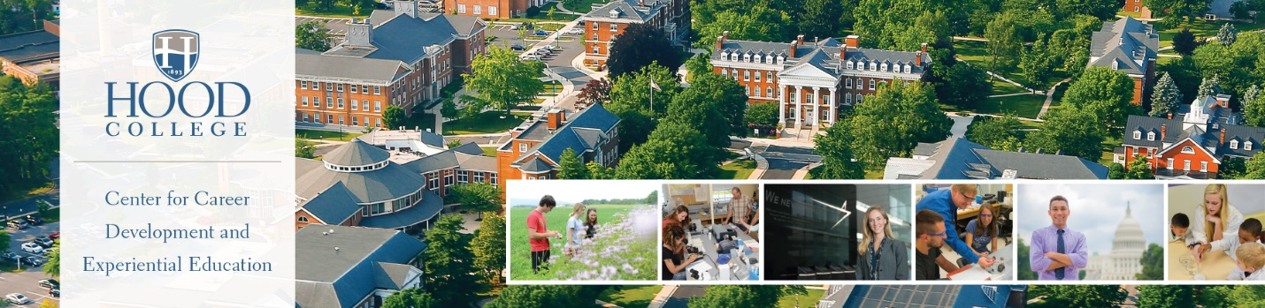
TIPS FOR INTERNATIONAL STUDENT JOB SEEKERS
Plan ahead: As an international student you face certain challenges and restrictions regarding the U.S. job market. Begin by getting your materials ready early – be prepared for a search to take 2 months or more.
Communicate clearly: Communication skills are very important. Use every possible resource available at Hood College to strengthen your resume, cover letters, LinkedIn accounts (etc.). All should reflect error-free, compelling content that is consistent with a U.S. format. Check and respond to email daily.
Use resources wisely: Attend on-campus events (job fairs, company information sessions, recruiting events), join off- and on-campus professional organizations, and meet with essential staff to build relationships and understand the hiring process.
Understand your strengths: Know your unique assets and academic training and focus on employers that have a strong need for all of those strengths. Companies that do business internationally are often looking for international employees that have cultural knowledge, academic depth, and language skills.
Network: Networking may be even more important for international students than for U.S. citizens. Networking simply means systematically making personal, written, or telephone contacts with relatives, friends, and alumni in the United States and back home who may be able to help you in your search. Each person you contact becomes a participant in your search. Fellow students from abroad who have gained some experience with the U.S. job market may be able to help you with your search as well.
Seek the right companies: In your research and networking efforts, concentrate on employers that have connections (offices, subsidiaries, marketing teams, sales forces) in your country of origin. These companies may have an interest in your working for them in this country, or to return to your home country after initial training in the United States. In addition to the resources on campus, contact your embassy. Often, foreign embassies maintain lists of contacts for employment. Contact them!

Page 1

FINDING OPPORTUNITIES
The best employment prospects for international students begins with identifying companies that will see you as an asset. These typically include global organizations that desire language skills, have respect for diversity, and/or have a need for knowledge of overseas economies. International students should also seek out organizations that have historically sponsored H1-B Visas.
Begin your search by using some of the following databases to find companies that hire international workers:
- MyVisaJobs - Information portal and online community for visa job hunters around the world. Major services include sponsor profiles, resources for job seekers, top 100 employers offering visa sponsorship and jobs.
- H1Base - Online, interactive database that allows international students to directly connect with the top sponsor companies. Free company resources are accessible and students may choose to upgrade their account for more advanced fee based services. Free services allow for three company searches per day.
- Immihelp.com - Job seekers can use the Immihelp searchable database to seek out employers who have historically sponsored international candidates. Located databases under the “Tools.”
- For International Jobs and Internships (not limited to the U.S.), check out iHipo.
- E-Verify is an online program run by the U.S. government that is used mostly by employers to check employee records and eligibility. Search for employers that provide work authorization and sponsorship.
- CareerShift – This is a job search tool offered by the Career Center. See instructions on page three of this handout on how to access this search engine.
SERVICES OFFERED BY YOUR CAREER CENTER
- Major & Career Exploration
- Civic Engagement Volunteer Opportunities
- Resume & Cover Letter Writing
- Internship Database & Paperwork
- Interview Preparation
- Job Search & Salary Negotiation Information
Register and create a profile in Handshake https://app.joinhandshake.com/. Find and schedule an appointment in Handshake or call (301) 696-3583, or stop by our offices on the second floor of the Apple building. Office hours are Monday through Friday, 8:30 a.m. – 5:00 p.m. Extended hours by appointment.

Page 2
LOGIN TO HANDSHAKE
Under the Campus Community tab on the Hood College website scroll down to the Career Center link. This will take you to the Career Center homepage. Click on the Handshake icon to access the site, be sure to use your Hood College email and regularly associated password.
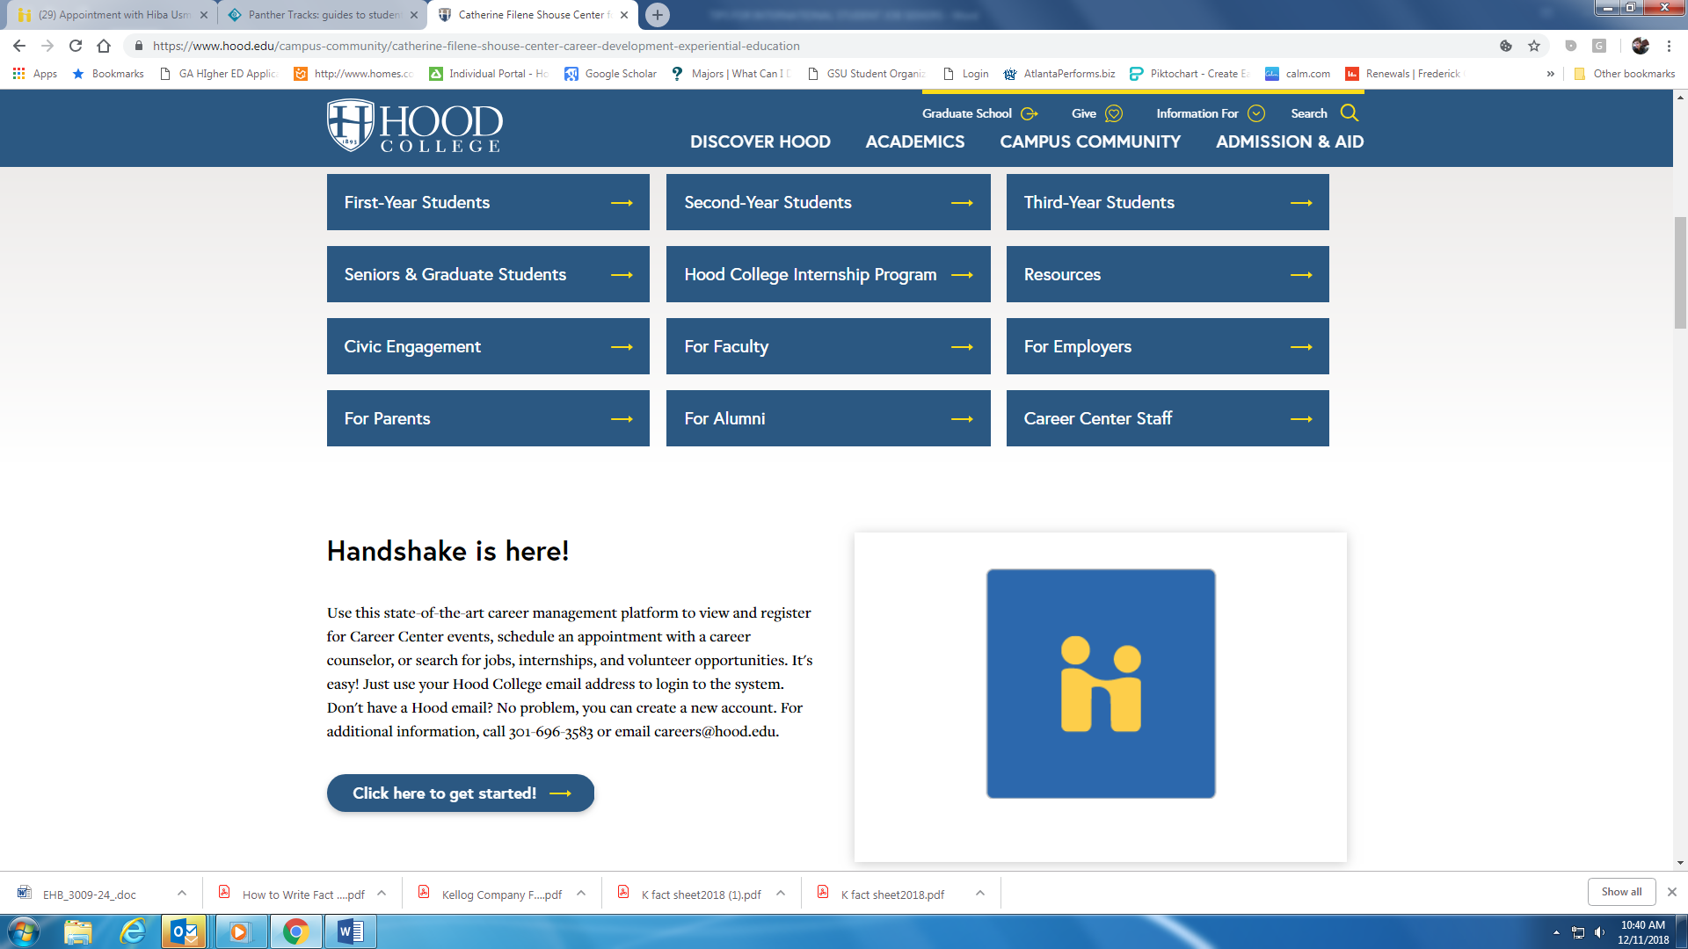
CAREERSHIFT
To access the CareerShift job search engine, https://www.careershift.com/?sc=Hood. Create a login and answer a few demographic questions at the start. You must use your Hood College email to access this site.
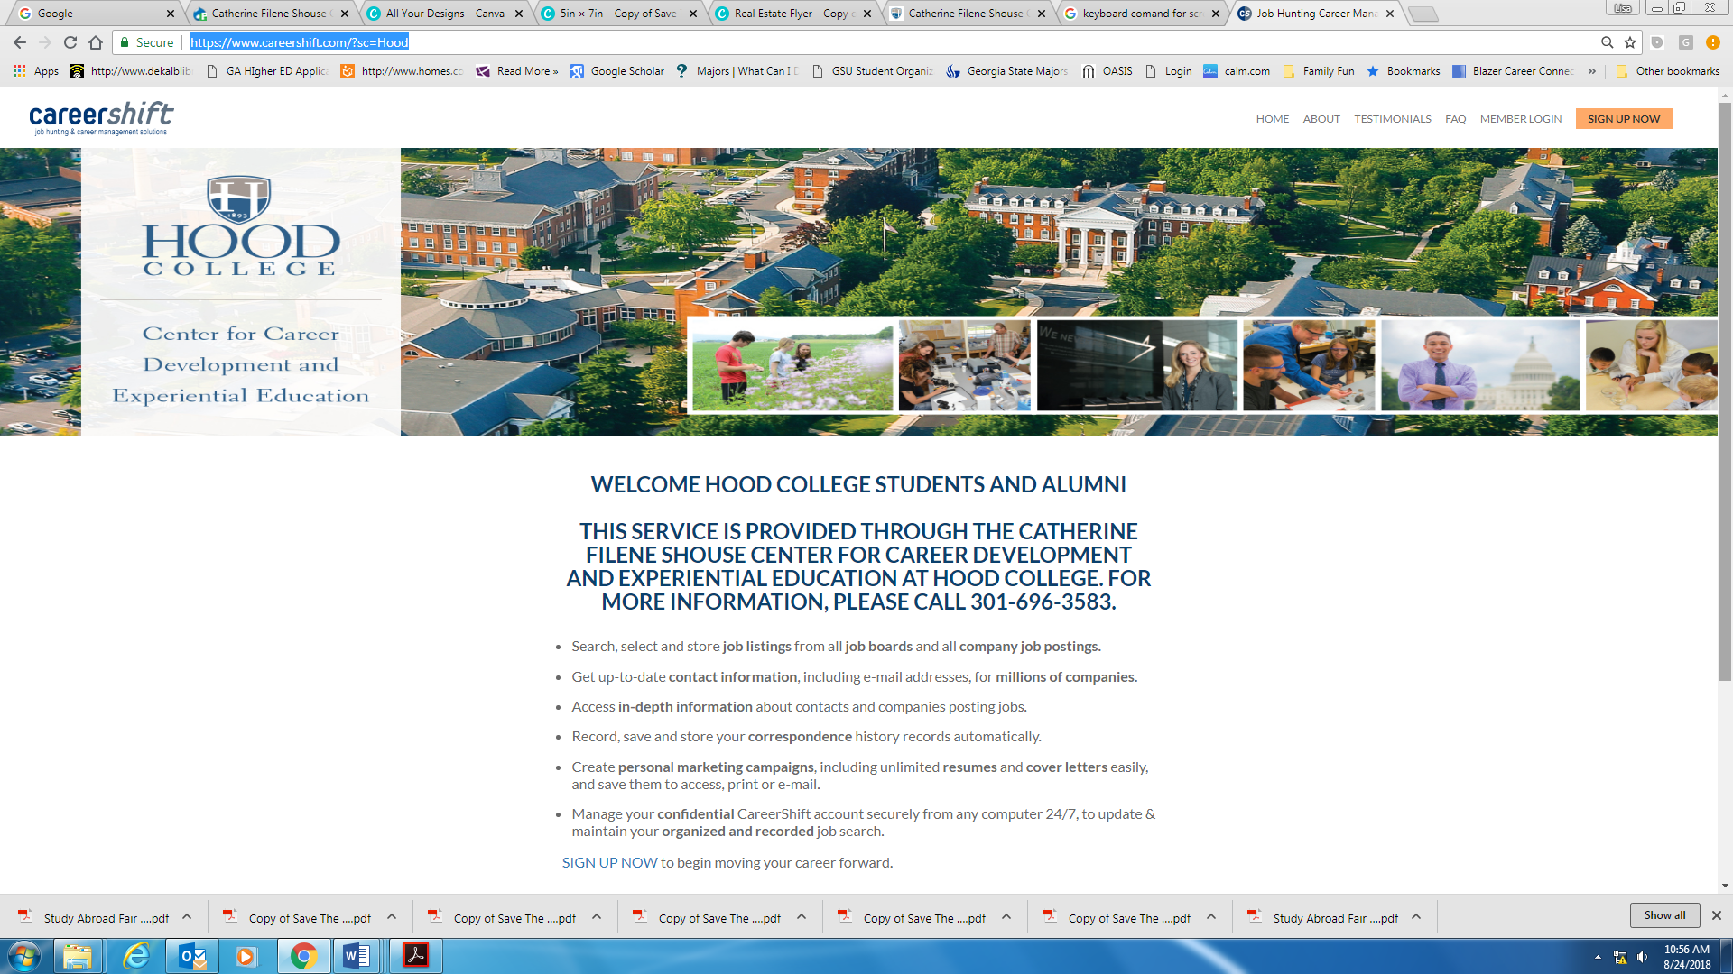
Page 3

