Honors Degree Progress Reports (DPR)
TO ACCESS THE DPR THAT INCLUDES HONORS:
- Go to this link
- Enter the student’s PCID number (PRECEDED by the letter P) and click “View Report”
- Scroll down to find the Honors Program section, which includes HON courses and language requirement (Honors students must complete a foreign language through 202 or equivalent)

HOW DO I FIND A STUDENT’S PCID NUMBER?
- In Self Service, search for your advisee
- The PCID number appears below the advisee’s name in the list (see below). It also appears if you click on their name.
- Don’t forget to add a capital P before the number!

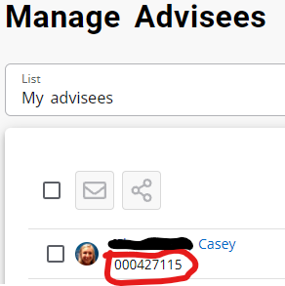

WHAT IF WE HAVE ADVISING QUESTIONS ABOUT HONORS?
- Check out the requirements for Honors in the catalog and on the website
- Review the attached PowerPoint on Honors requirements (feel free to share with students)
- Email Shannon (kundey@hood.edu) or me (marcus@hood.edu) with questions, or refer students to us

