Here’s a step-by-step guide on how to change your signature in Outlook on a Mac.

1. Launch Outlook on your Mac by clicking on the Outlook icon in your dock or searching for it using Spotlight (Cmd + Space).

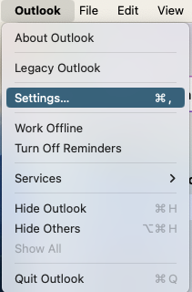
2. In Outlook, click on “Outlook” in the top menu bar. Select “Preferences” or “Settings” (depending on the version) from the dropdown menu.

3. In the Preferences window, find and click on “Signatures.” It’s usually under the “Email” section.
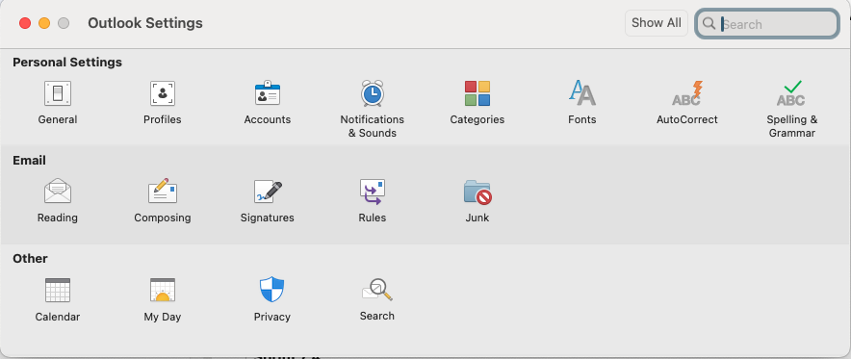

4. In the Signatures window, you’ll see a list of your existing signatures. Select the signature you want to change and press “Edit” or click the “+” button at the bottom to create a new one.
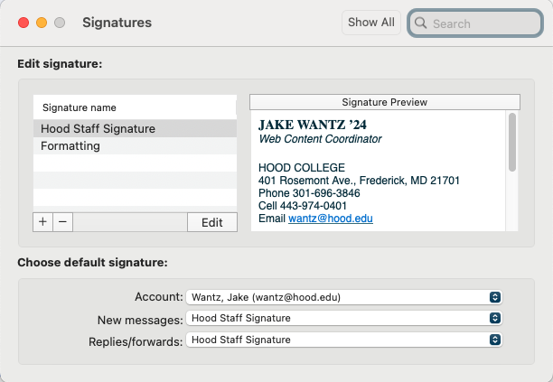

5. In the text box, edit your signature by filling in this signature below and copy/pasting it over in the box. DO NOT format the text, add links or include images other than the ones shown.
FNAME LNAME
Title

HOOD COLLEGE
401 Rosemont Ave., Frederick, MD 21701
Phone 301-696-xxxx
Email email@hood.edu



6. After editing your signature, set it as the default for new emails or replies by using the “Default Signatures” section at the bottom right of the Signatures window.
7. After making your changes, click “Save” (if applicable) and then close the Signatures window.
8. Create a new email to test if the signature appears as expected. Go to “File” > “New” > “Email” and check if your updated signature is automatically added.

